Bellfield College Senior Uniform
Senior Girls Summer Uniform (7-12) | Senior Girls Winter  Uniform (7-12) | Senior Girls Sport  Uniform (7-10)
White long sleeve cotton shirt | White long sleeve cotton shirt | Long teal polo shirt with logo
Long striped summer skirt | Long teal check winter skirt | Striped cotton long polo pants (unisex)
Seniors – Teal head scarf | Teal wool blend knitted jumper | Long White Sport socks
Bellfield College logo bag | Teal blazer | School hat
White school socks to cover the shin or longer | Charcoal lycra tights | Microfibre long jacket
Black hard leather hard sole school shoes | Black hard leather hard sole school shoes

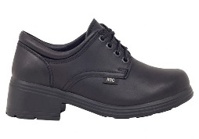  GIRLS  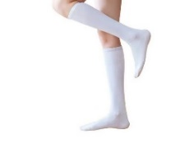  These white socks should also be worn on Sport days for both boys and girls | 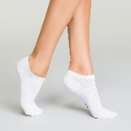  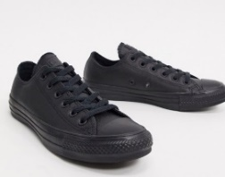

Senior Boys Summer Uniform (7-12) | Senior Boys Winter  Uniform (7-12) | Senior Boys Sport  Uniform (7-10)
White short sleeve cotton shirt | White long sleeve cotton shirt | Teal polo shirt with logo
Charcoal wool blend long pleated pants | Charcoal wool blend long pleated pants | Striped cotton long polo pants (unisex)
Grey school socks to cover the ankle | Grey school socks to cover the ankle | White sport socks
Seniors - School tie | Teal wool blend knitted jumper | School hat
Bellfield College logo bag | Teal blazer | Microfibre jacket
Black hard leather hard sole school shoes | Black hard leather hard sole school shoes

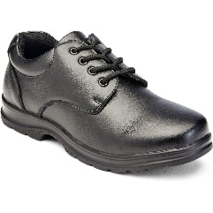  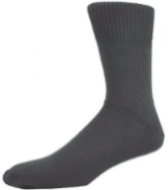  BOYS  These white socks should also be worn on Sport days for both boys and girls | 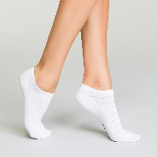  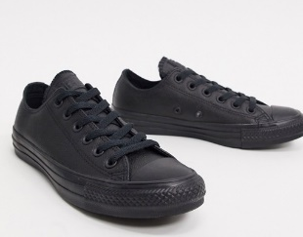

Sport Uniform Sports Uniform is worn for PE PRACTICALS and Sport days only. Please refer to the student timetable and CANVAS classroom for PE practicals days.
- Year 7 - Year 8 students attend sport on Wednesday afternoon.
- Year 9 - Year 10 students attend sport on Friday afternoon.
Students not in the correct and full summer uniform will be issued afternoon detention.
NOTE ** Our College uniform shop stocks open toe tights suitable for ablution
Not wearing leather school shoes is a WHS risk and students will not be allowed to participate in practical lessons (ie Food Technology)

