**Bellfield College Junior School SUMMER Uniform**

Two-piece sport hijab in white.

Long summer sport pants

Long length polo shirt with logo

White sport shoes

White sport socks

Grey socks

Black leather shoes

Charcoal wool blend pleated pants

Charcoal Sun Cap

Striped short sleeve cotton shirt

Polo shirt with logo

Ankle Length check pinafore

White socks

Black leather shoes

White long sleeve cotton shirt (under pinafore)

Charcoal Sun Cap

All hijabs worn must be white and should be regularly cleaned. Hijab headbands should be white **only.**

White sport shoes

White sport socks

Microfiber school sport shorts

Polo shirt with logo

Black leather shoes

White socks

White short sleeve cotton shirt (under pinafore)

Check pinafore

K-3 Full brim hat with logo.

Black leather shoes

Grey socks

Charcoal shorts

K-3 Full brim hat with logo.

Striped short sleeve cotton shirt

**Bellfield College Junior School WINTER Uniform**

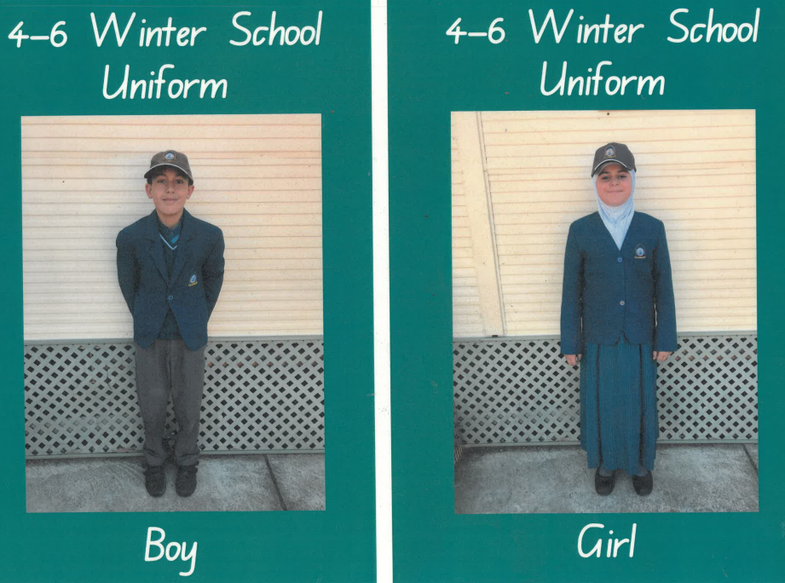

White long sleeve cotton shirt (under pinafore)

Teal wool blend knitted jumper (under blazer)

Teal Blazer (Girls)

Ankle length Teal check pinafore

Charcoal tights

All hijabs worn must be white and should be regularly cleaned. Hijab headbands should be white **only.**

Charcoal Sun Cap

Grey socks

Charcoal Sun Cap

Striped long sleeve cotton shirt (under jumper)

Teal Blazer (Boys)

Teal wool blend knitted jumper (under blazer

Charcoal wool blend pleated pants

Black leather shoes

Black leather shoes

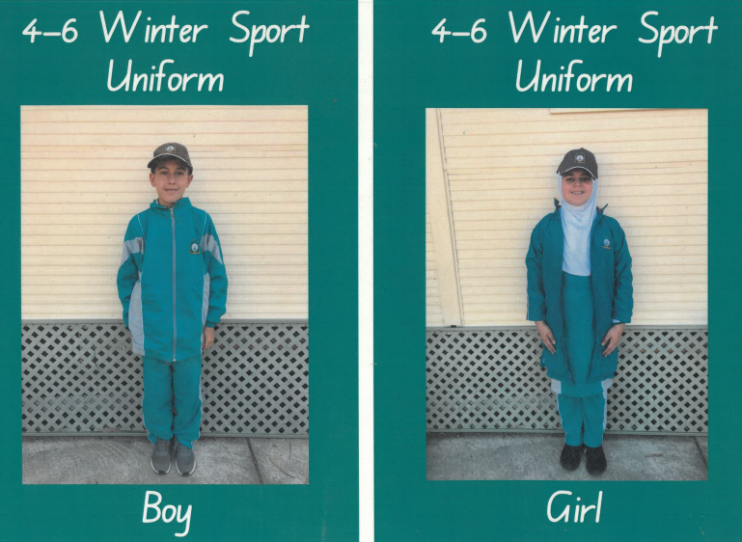

Long length polo shirt with logo

Polo shirt with logo

White sport socks

White sport shoes

Unisex microfiber tracksuit

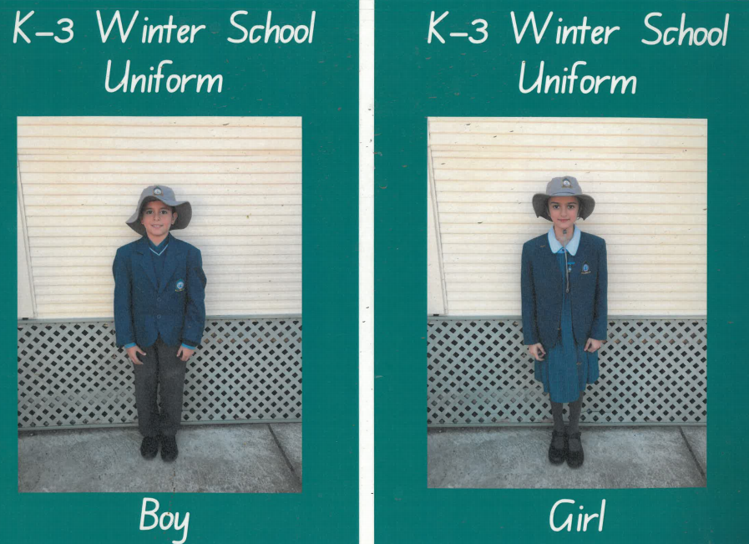

White long sleeve cotton shirt (under pinafore)

Teal check pinafore

Charcoal tights

Black leather shoes

Teal Blazer (Girls)

K-3 Full brim hat with logo. Girls hair ties must be in the school colours (white, teal or charcoal)

K-3 Full brim hat with logo.

Black leather shoes

Grey socks

Striped long sleeve cotton shirt (under jumper)

Charcoal wool blend pleated pants

Teal Blazer (Boys)

Teal wool blend knitted jumper

Teal wool blend knitted jumper

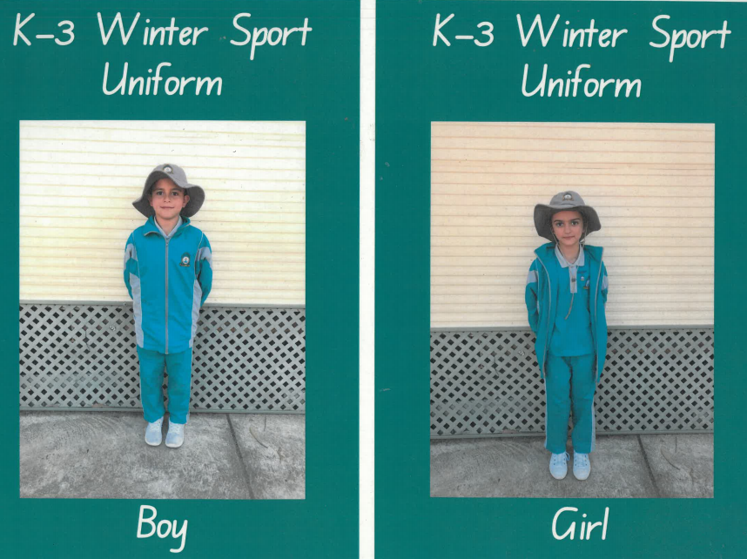

Unisex microfiber tracksuit

Polo shirt with logo

White sport socks

White sport shoes